# **Activity Description:**

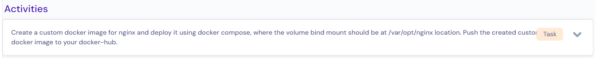

# **Pre-conditions:**

1. EC2 instance has been created.
2. Docker has been installed on EC2 instance.
3. docker-compose component has been installed.

# **Create a custom docker image for nginx.**

We Build a docker image usingCreate a Dockerfile with below content to create a docker custom image.

# Use the official Nginx image as the base image

FROM nginx:latest

# Set the working directory

WORKDIR /usr/share/nginx/html

# update packages

RUN apt update

# Create a temp directory

RUN mkdir temp

# Expose port 80 (HTTP) and 443 (HTTPS)

EXPOSE 80 443

# Mount volume at /var/opt/nginx

VOLUME /var/opt/nginx

CMD ["nginx", "-g", "daemon off;"]

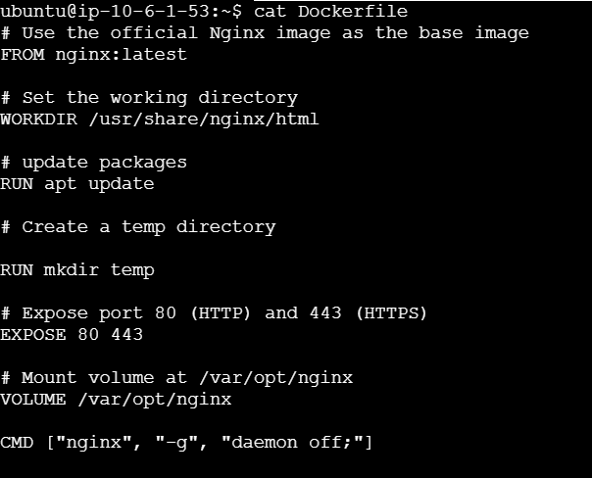

# **Build the Docker Image:**

docker build -t 17051991/nginx_custom:latest .

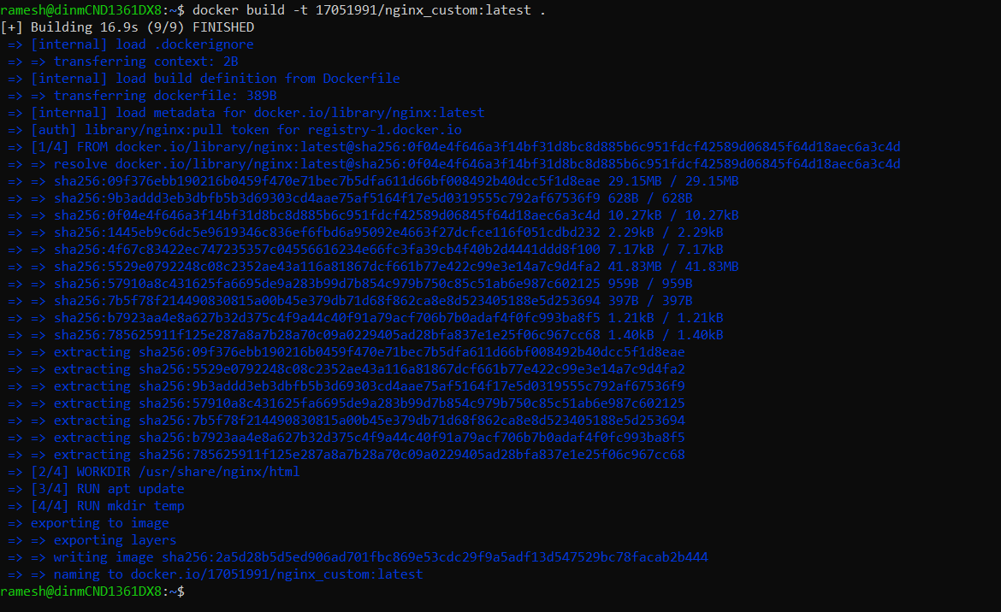

# **Push the Docker Image to Docker Hub:**

docker login

docker push 17051991/nginx_custom:latest



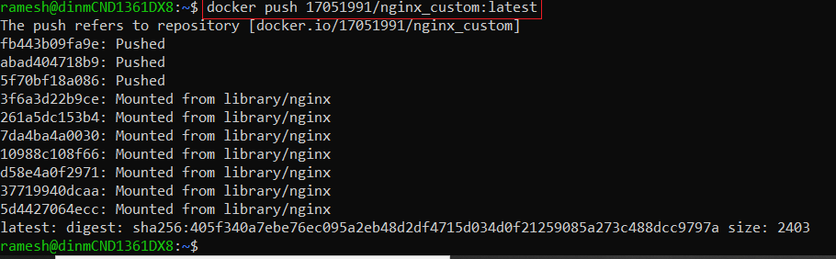

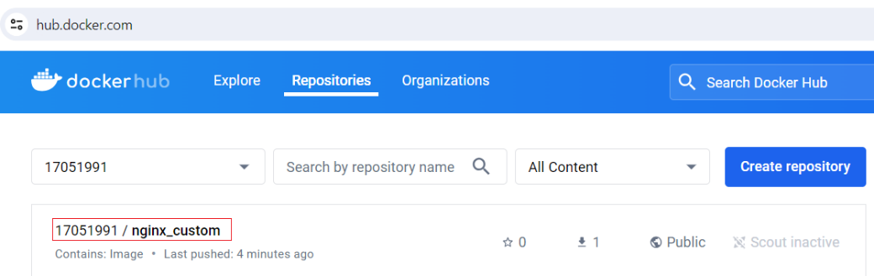

# **Create Docker Compose file (docker-compose.yml):**

version: '3.8'

services:

nginx:

container_name: my_nginx

image: 17051991/nginx_custom:latest

ports:

- "80:80"

- "443:443"

volumes:

- /var/opt/nginx:/var/opt/nginx

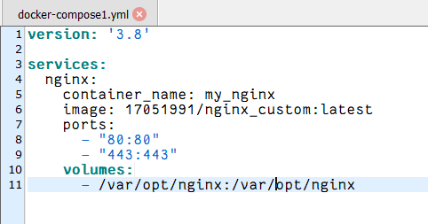

# **Run Docker Compose:**

docker-compose up -d

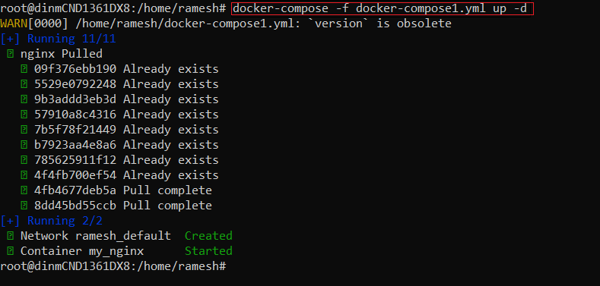



# Verification:

1. Login to container and create a file inside a mounted path /var/opt/nginx

1. Logout from container and check the same file whether it is created in docker host or not.

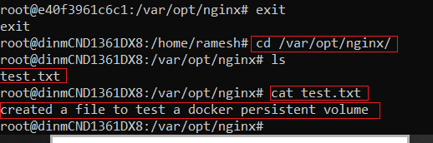

1. Delete container using docker-compose and check the same file where it exists on docker host or not.

Yes, file is still persist on docker host even docker container got removed.



